
PROGRAMMING 1
BACT 750I

April 17, 2026
WHITECLIFFE

NAME – PATEL MEET NAGJIBHAI
Student id – 20260261
Subject code – BACT750I
Subject – PROGRAMMING I
Date – 17-04-2026
College Name – WHITECLIFFE
Tutor Name – PINAL SHAH
Contents
Problem- 1 1
Explain - 1
Problem - 2 1
Explain – 2
Problem - 3 2
Explain – 2
Problem - 4 3
Explain – 3
Problem - 5 4
Explain – 4
Problem- 6 5
Explain – 5
Problem - 7 6
Explain – 6
Problrm – 8 6
Explain – 6
Problem - 9 7
Explain – 7
Problem - 10 8
Explain – 8
Problem - 11 8
Explain – 9
Problem - 12 9
Explain – 9
Problem - 13 9
Explain – 10
Full code of task -1 11
Program plan 11
The line - 1 12
The line -2 12
The following three lines: 13
The lines - 6 13
The statement 13
The line - 8 13
The next lines- 9 13
The line - 10 14
The line -11 14
The loop -12 14
Inside the loop, -14 14
The condition 15
Provided the condition is true, the program gathers new information about items and performs: 15
Add the total: 15
Once the loop is finished, the line. 15
The function then calls 16
Finally, the line 16
Strong Conclusion: 16
Part-1 outpute 16
TASK 2 PLAN: 17
Code explation: 17
The line - 55 17
The condition 17
In the event that the condition is true, the line 17
The next line 18
Else statement: 18
The final line 18
Strong Conclusion 18
Task-2 output 19
(Task 3 ) FULL CODE EXPLANATION 20
The role starts with. 20
The line - 73 20
The next line - 74 21
The line - 75 21
The lines -76 21
The line - 78 21
The line -79 21
The line -80 22
Strong Conclusion: 22
Task-3 output 23
Task-4 24
Main Window Creation 24
Global Variables 24
Task-4 outputs. 29

Problem- 1

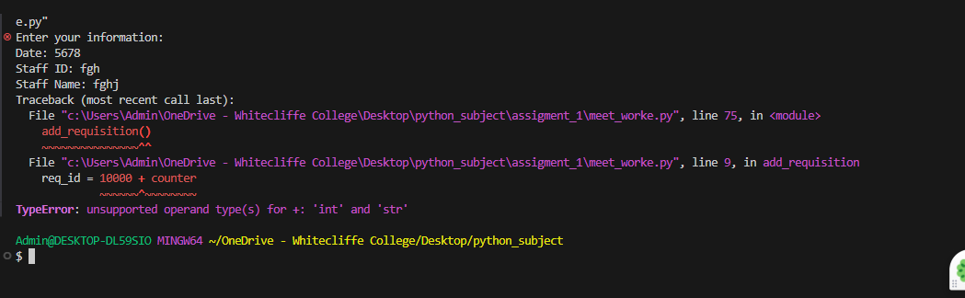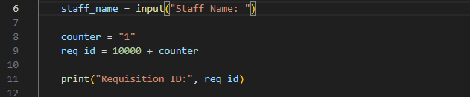

Explain -
I have had an experience with TypeError, as I attempted to sum up an integer (10000) and a string (counter). Input in Python gives a string and thus arithmetic operations do not work with mixed types. I have worked around this by converting the string to an integer with int() function. Both of the values became integers after conversion, and addition did not give any errors.
Problem - 2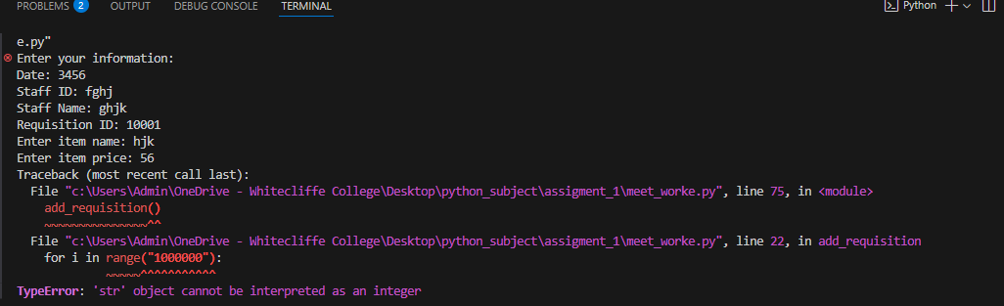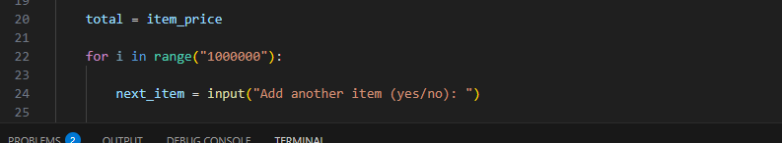

Explain –
I had a TypeError, which is str object cannot be understood as an integer. This was due to the fact that I applied a string value within the range () function whose only method is to take the integers. The value must have been input() as it returns a string. To overcome this, I converted the string into an integer with the help of int. In the converted form, range() was functioning properly, and the code was run successfully.

Problem - 3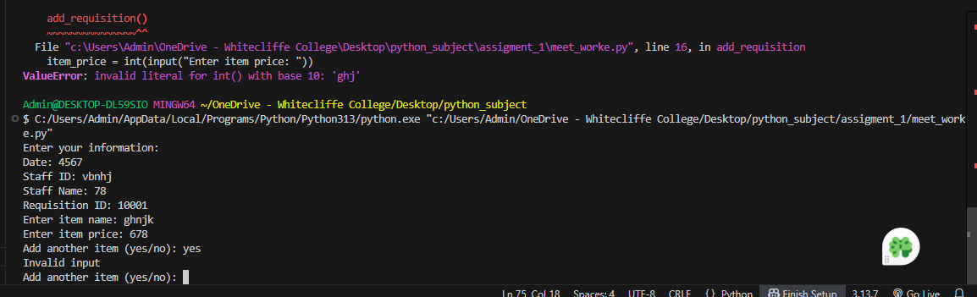 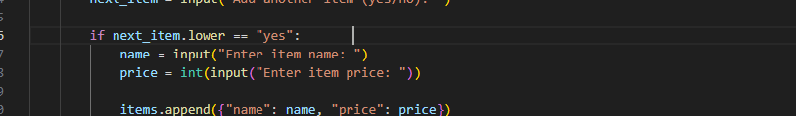

Explain –
I had a ValueError: invalid literal for int with base 10 since I attempted to convert a non-numeric value (such as a string such as ghj) into an integer with int. This occurred when accepting user input on price of items. int() only takes numbers and thus it failed. I resolved this by making sure that the user only types in numbers or by validating the input and then conversion.
Problem - 4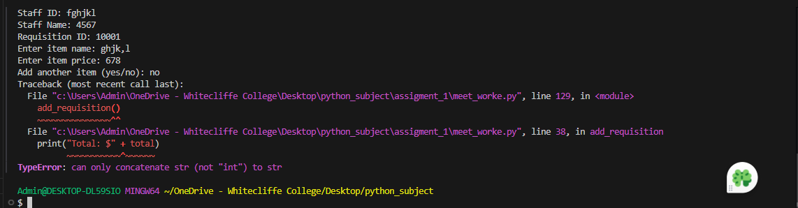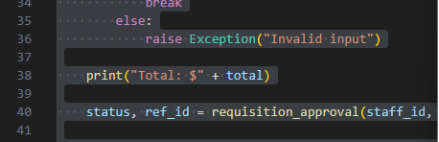

Explain –
I have a TypeError: can only concatenate str (not int) to str. This occurred since I attempted to add a string (Total: ) with an integer (total) with the operator +. In Python, it is not possible to directly concatenate strings and integers. To overcome this I either changed the integer to a string with str, or I used a comma in print. Following this, the output could be shown without any errors.
Problem - 5 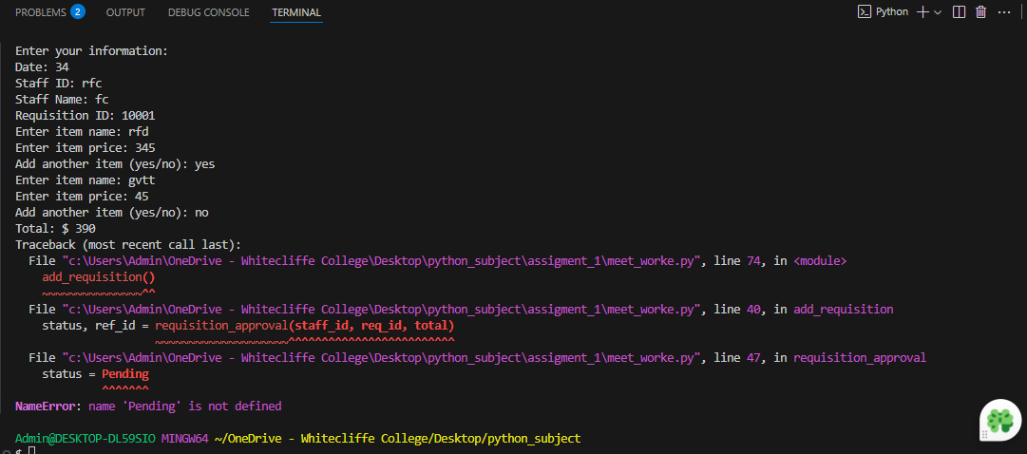 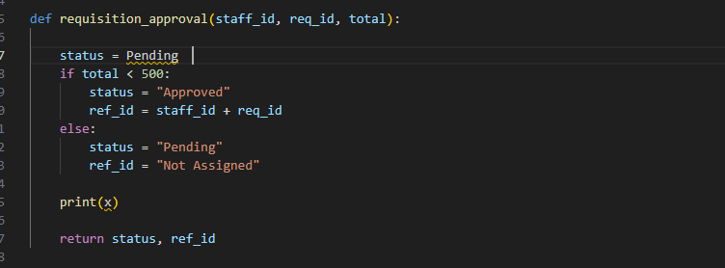

Explain –
This is the mistake that I made since I wrote Pending without quotes and this made Python think that it is a variable rather than a string. It was not defined, and thus raised a NameError. I have resolved this by putting it in quotations as Pending. This rightly causes it to become a string value and the program is run successfully.

Problem- 6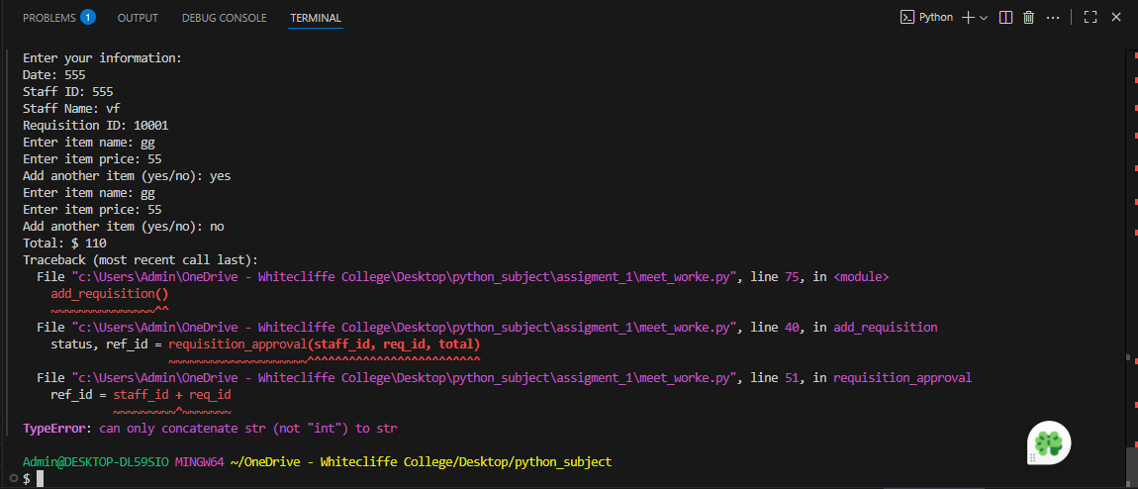
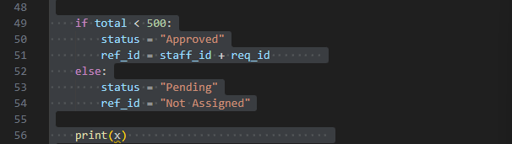

Explain –
This error happened when I tried to join a string with an integer using +. With Python, you cannot concatenate types. The problem was in staff_id +req_id. I resolved it to convert integers to strings with str() or formatting. This makes sure that both values are strings and concatenation is correct.

Problem - 7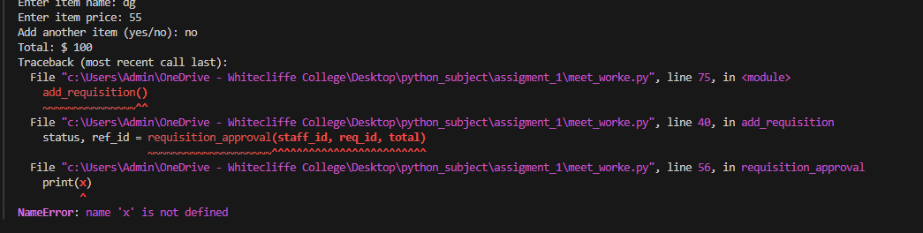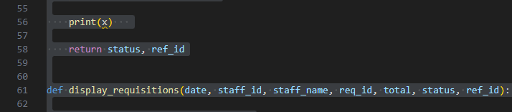

Explain –
This mistake was made due to my attempt to use or print a variable that was not defined x. Python involves declaration of variables. I resolved this by defining x prior to its use or eliminating the redundant statement. Once the program was fixed to use the variables correctly, the program ran successfully without any errors.

Problrm – 8 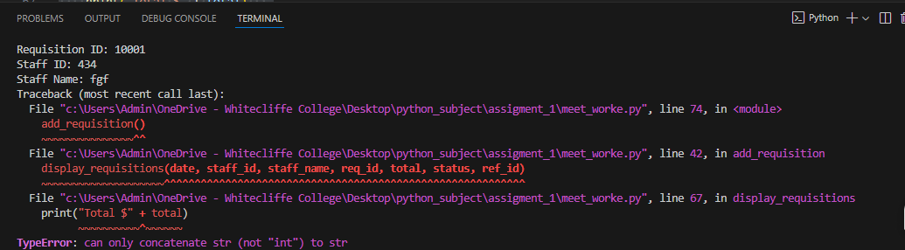 (GeeksforGeeks, 2026) (python.org, 2026) (pythonexamples.org, 2026)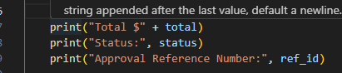

Explain –
This mistake was manifested in the printing of the statement: Total: + total where total was an integer. The combination of the types of strings and integers cannot be performed directly in Python. To solve this I turned the integer into a string with str(total), or I printed it out with Total: total. This guarantees proper output with no typing errors.

Problem - 9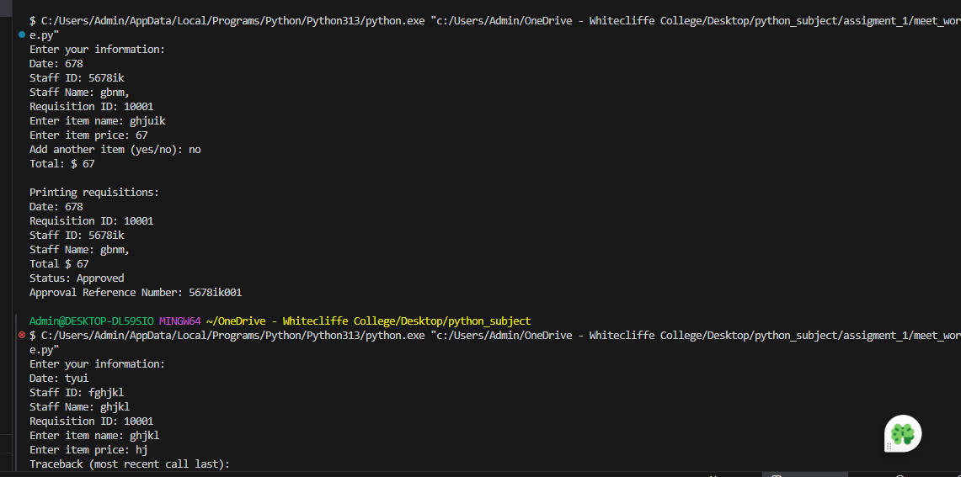

Explain –
This is the mistake that happened when changing the input into an integer with the help of int() but the input was not numeric, it had non-numeric characters such as letters. Int() only accepts numbers, and thus failed. I have solved this by either making the user input numeric values or by input validation prior to conversion. This will avoid invalid input errors.

Problem - 10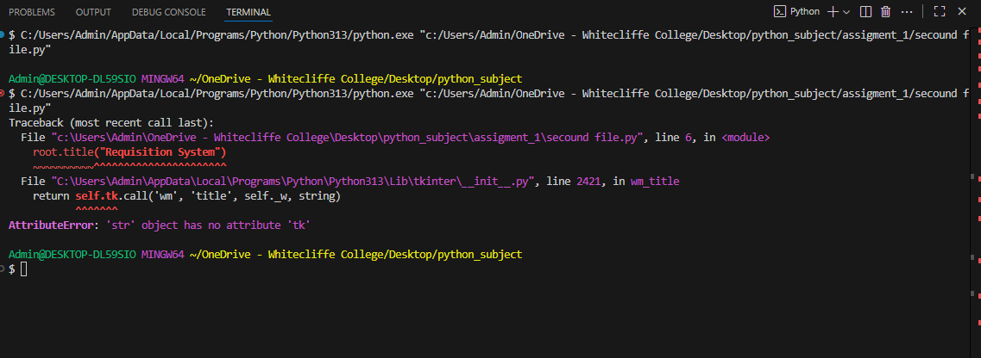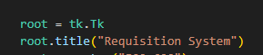

Explain –
The mistake occurred due to the fact that I gave a string (such as root) rather than an object of a Tkinter window to a widget. Tkinter requires a good root object to be established with the Tk. The solution I came up with was to put up a proper root window (root = Tk() ) and passing it to the widgets. This rectified the error of attributes.

Problem - 11
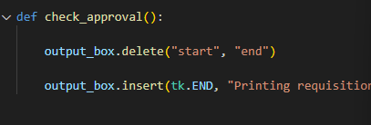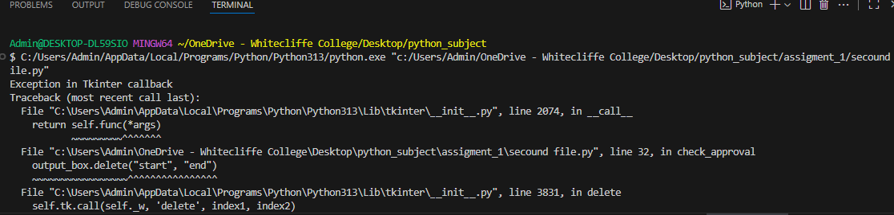

Explain –
This was a mistake within one of the Tkinter functions when attempting to delete or edit a widget in an inappropriate way. This problem was probably caused by incorrect reference to a widget or incorrect use of a method. I was able to fix it by making sure that the appropriate widget object is utilized and using appropriate Tkinter techniques. After fixing references, the callback worked correctly.

Problem - 12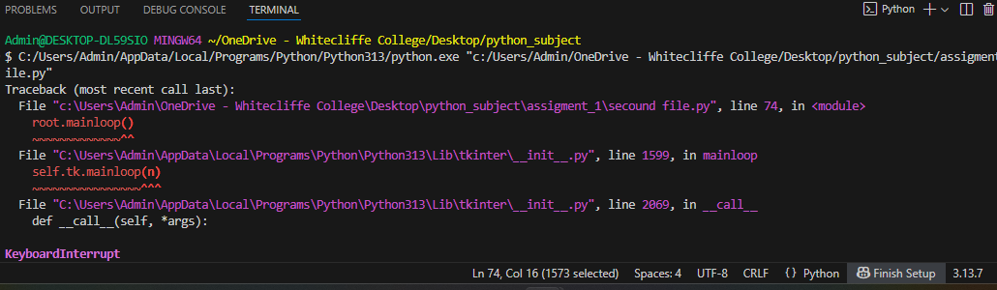
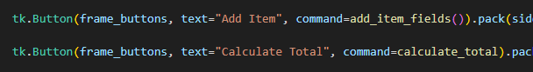

Explain –
This failure manifested itself when I terminated the program manually (by pressing Ctrl + C or interrupting program execution). Not code issue, it is a user interruption. No fix is required. I just left the program to run normally, without interruption and it successfully ran without this error.

Problem - 13
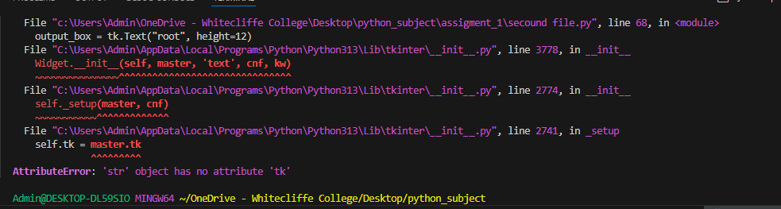


Explain –
This bug is comparable to the previous Tkinter bug. It happened since a Tkinter widget or root object was not used but a string. Tkinter needs to have good objects of GUI elements. I got around this by properly creating and passing the Tk() instance. Once this was corrected, the GUI was able to work correctly without errors.

Full code of task -1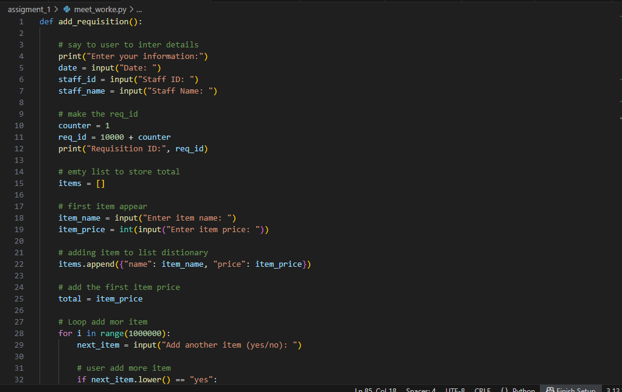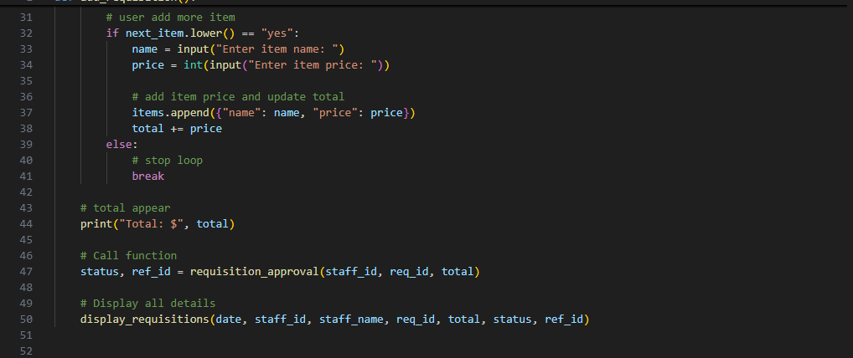

Program plan
The requisition system is intended to be a simulation of the purchase request process in the real world. The program is split into three major functions which perform a particular task. This is based on the idea of modular programming, which decomposes a large problem into small, manageable components.
To begin with, user input, including date, staff ID, and staff name, is taken into consideration by the system. It then enables the user to put in item information such as the name of the item and the price. The program parallels many items with a loop thereby making it flexible to the user.
Once all the items have been gathered, the program calculates the total cost of the requisition. On this total, the system uses decision making logic to either approve or hold on the requisition.
Lastly, the whole information gathered and processed is presented in structured format. The system also makes sure that the output is in the format needed which contains the staff information, total amount, status information, and approval reference number.
In general, the program employs such important principles of programming as:
Handling of inputs and outputs.
Functions (modularity)
Dictionaries and lists (data storage).
Loops (iteration)
Conditional statement (decision making)
FULL CODE EXPLANATION (Task 1 )
In-depth Theory Explanation with Code References.
The function begins with the statement

The line - 1

which defines a user-defined function. In programming theory functions are applied in the decomposition of a big problem into small, manageable ones. This enhances the readability, reusability and maintainability of code. In this scenario, the task that the function will undertake is to deal with the entire requisition process that is needed in Task 1.

The line -2
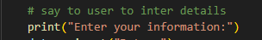
is an output statement that directs the user. In theoretical terms this is interaction with the user interface, in which the system talks to the user.

The following three lines:
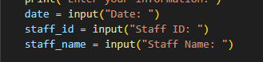
use the input() to gather user data. This shows data acquisition in which the user inputs data which is stored in variables. These are variables that are containers in memory that store the information about the user to be used later on in processing and display (Task 3 requirement).

The lines - 6
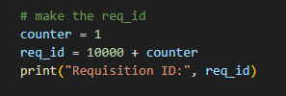
show arithmetic calculations and use of a variable. The purpose of this logic is to generate a unique Requisition ID. Base value (10000) is used to ensure that all IDs are in a similar format whereas the counter is used to make each ID unique. This is indicative of identifier generation in systems.

The statement

is used to show the generated ID. This will be significant to user confirmation and traceability of the requisition.

The line - 8
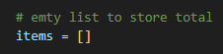
creates an empty list. Theoretically, a list is a dynamic data structure, which enables storing several values in one variable. It is applied in this case, since the number of items is not predetermined, and the user can add several items.

The next lines- 9
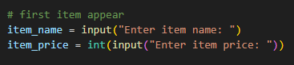
get the first item information. The int() is an example of type casting, which is used to convert the string input into an integer. This is needed since mathematical operations (e.g. addition) cannot be applied to strings.

The line - 10
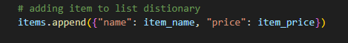
if item_name and item_price are known, then insert the information by adding it to the items.
relies on a list and dictionary. The dictionary contains attributes of the items (name and price) in the form of key-value pairs and the list contains several such dictionaries. This illustrates the structured data organization that is significant in real life application.

The line -11
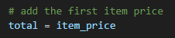
initiates the overall cost. This is in the idea of initialize where a variable is assigned an initial value to be used in subsequent calculations.

The loop -12
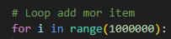
is used to repeatedly execute a block of code. This is theoretically iteration. The value of range is very large to simulate an endless loop, which lets the user continue adding items as long as he/she wants to.

Inside the loop, -14
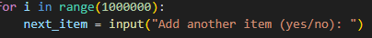
takes input and uses it to manage the program. This brings in decision making that is driven by the user.

The condition

shows conditional statements (selection). The input can be converted to lower case, making the comparison case-insensitive, using the method: .lower() This enhances the user experience and robustness of the program.

Provided the condition is true, the program gathers new information about items and performs:
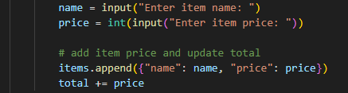
The new item is added to the list using the append() method, and total + price is an accumulator pattern example, with a variable being changed repeatedly within a loop. It is a basic idea in programming that is applied in adding values.

Add the total:
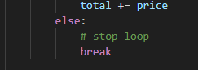
is executed. It is a loop control statement that is used to end the loop immediately. It makes sure that the program does not request additional items when the user does not want to do it anymore.

Once the loop is finished, the line.
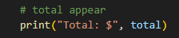
shows the resultant total calculated. This fulfills the requirement of Task 1 to compute and show the total requisition cost.

The function then calls
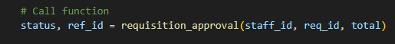
This shows the invocation of functions and the passing of data where variables are used as argument to a different function (Task 2). The function provides several values (status and reference ID) that are saved in variables.

Finally, the line
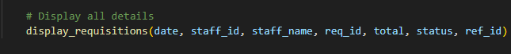calls another function to display all results. This demonstrates the interaction of various functions to fulfil system workflow, which is another important concept of modular programming.

Strong Conclusion:
Task 1 is well implemented using add_requisition() function that combines several programming features like input handling, arithmetic operations, lists, dictionaries, loops, conditionals, and function calls. Every line of code will help to gather, process, and set up requisition data, making the system flexible, user-friendly, and in line with real-world requisition procedures.

Part-1 outpute
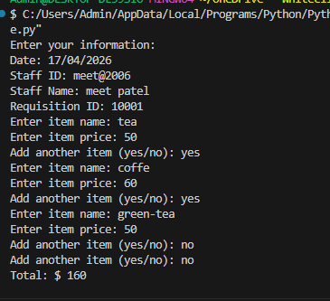

TASK 2 PLAN:

Task 2 will aim at implementing the approval logic of the requisition system. This component of the program will be charged with determining whether a requisition can be approved or put on hold depending on the overall cost.
Task 1 provides the necessary data (staff ID, requisition ID and total amount) to the function. It then uses conditional logic to determine whether the cumulative cost is lower than a certain amount (500). According to this condition, the system gives an approval status and issues a reference number when approved.
This functionality makes sure that the business rules are properly applied and the decision making process is automated as well. It also readies the results (status and reference ID) as to be used in Task 3 to display.

Code explation:
that specifies a role that manages the approval process. This shows modular programming, decision making logic is not integrated with input and output processes. The staff_id, req, and total data are the data sent by the last function demonstrating that there is a transfer of data between functions.

The line - 55
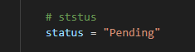
prepares the status variable. This is based on the idea of default initialization, in which a variable is assigned an initial value, and this value is then assigned to the variable prior to any conditions being enforced. In line with the system requirements, all requisitions should have an initial status of Pending.

The condition
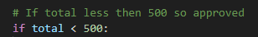
inserts a conditional statement, a fundamental concept in programming and is used in decision making. This condition will verify that the sum of the cost of the requisition satisfies the automatic approval criteria.

In the event that the condition is true, the line
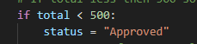
updates the status. This illustrates the variable reassignment, which is changing the value of a variable by a condition. This directly adheres to the criteria that the total value of requisitions under 500 should be accepted.

The next line
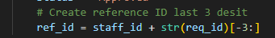
creates the approval reference number. This line is a combination of several programming concepts:
Type conversion (str(req_id)): Changes the requisition ID, which is an integer, into a string to enable it to be joined to another string.
String slicing ([-3:]): Extracts the last three digits of the requisition ID.
Concatenation (staff id +...): Appends the staff ID with the digits extracted.
This satisfies the need to come up with a reference number based on the staff ID and the last three digits of the requisition ID.
In case of the condition being false, the program runs the else block:

Else statement:
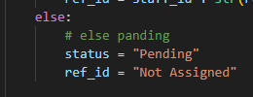
This is the other avenue in the decision structure. In case the total cost amount is 500 or above, the requisition will be left pending and no reference number will be created. The Not Assigned will provide clarity in the output.

The final line
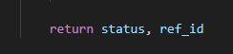
illustrates the idea of multiple values being the result of a function. This will enable the function to return the approval status and the reference ID to the primary function (add_requisition()), and this will facilitate a smooth flow of data throughout the system.

Strong Conclusion
Task 2 is successfully implemented by the requisition_approval() function which uses conditional logic to determine the approval status of a requisition. It employs important programming terms like decision-making, string manipulation, type conversion and multiple return values. Adhering to the outlined business rules, the function facilitates proper and efficient approval processing, which is crucial to the overall functionality of the system.

Task-2 output
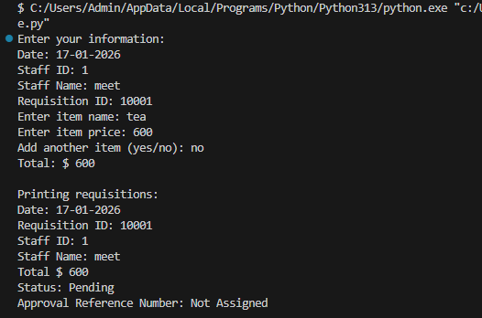
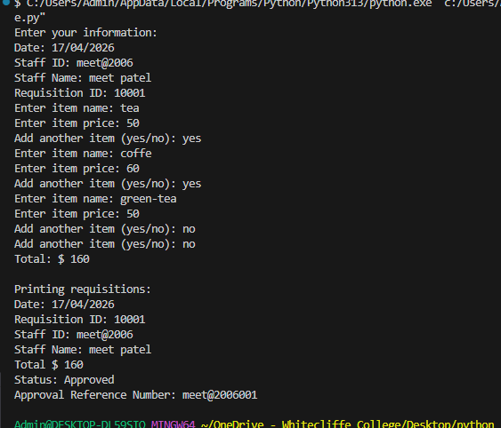

(Task 3 ) FULL CODE EXPLANATION

The role starts with.
that is what a purpose is that needs to show the details of the requisition. This demonstrates the principle of modular programming, in which the functionality of the output is decoupled with the input and processing. The parameters are data that are received by the preceding functions, which show data sharing among functions.

The line - 73
displays a heading of the output. The n character symbolizes a newline that enhances the readability of the output, by creating some spacing. This illustrates the principle of output formatting that plays an important role in presentation of data.

The next line - 74
shows the date typed in by the user. This is an indicator of how data is stored and how it is retrieved and presented, which is component of data output operations.

The line - 75
shows the id of the requisition generated by the system. This will make sure that every requisition is identifiable, which will be crucial in tracking and record-keeping.

The lines -76
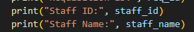
show the personnel information. These values have been gathered in Task 1 and they are presented currently to verify the identity of the requester.

The line - 78
shows the cost of the requisition. This value has been computed above indicating the reuse of processed data. This illustrates the idea of data uniformity of functions.

The line -79
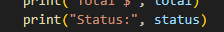
shows its approval of the requisition or pending. This value is based on the choice made in Task 2, which demonstrates the relationships between various components of the program.

The line -80
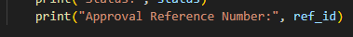
shows the number assigned when approved. When the requisition is approved a valid reference ID is displayed otherwise it indicates Not Assigned. This guarantees completeness and clarity of the output.

Strong Conclusion:
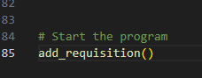
Task 3 is effectively accomplished by the display_requisitions() function, which ensures that all the requisition information is displayed in a form that is easy to read. It illustrates important programming concepts like output formatting, usage of variables, and interactions between functions. The combination of data in Task 1 and Task 2 makes the system user-friendly and effective because by combining the two functions, the final output will correctly represent the whole requisition process.

Task-3 output


Task-4
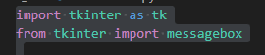
This line brings in the Tkinter library, which is the inbuilt Python module of developing graphical user interfaces (GUI). The as tk keyword is used to form an alias, which the programmer can use in place of
typing the entire name tkinter multiple times. This enhances readability and makes the code available in a concise form.
This line brings in the messagebox module of Tkinter that offers a set of functions to use a popup dialog box like an error message, warning, and confirmation. In this program, it is primarily applied to display error messages in case of filling in of required fields.

Main Window Creation
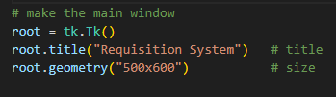
The following line throws up the principal application window. The Tk() method is used to start the Tkinter system, and gives back a root window object. This root will serve as the primary container to which all the widgets (buttons, labels, input fields) are going to be added.
This determines the name of the window which is placed at the top of the application. It will assist the user to learn the program.
This determines the number of pixels in the window. Its width is 500 pixels and the height is 600 pixels. It provides the interface with sufficient space to show all the components appropriately.

Global Variables
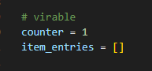
This is the variable that will be utilized to create a requisition ID. Every time a requisition is generated, this counter gets incremented by 1 and IDs are not repeated.
This is a list that holds all item input fields (name and price) that is empty. The user can add many items to the list and each item will be represented as a tuple stored in it which will then enable the program to operate on many items dynamically.
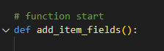
This is what constitutes a function by which the user can add dynamically several item input fields. When the “Add Item” button is clicked, it is activated.

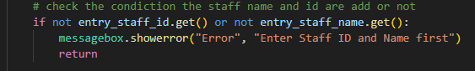
This verifies the fields staff ID or staff name are not empty. The.get() method will be used to retrieve the text that is typed by the user. When one of the fields does not have an element, then the condition is true.
This will show an error message as a popup to alert the user that they should get details of the staff first before adding items. This enhances user-friendliness and avoids wrong input streams.
This halts the execution of the function in case the condition is not met and no additional code is executed.
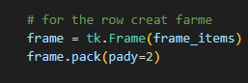
This is a new frame (container) within the main item frame. The frame will contain a row of each item, which will help arrange the layout.
This puts the frame in the window with the pack layout manager, and spacing between rows with vertical spacing (pady=2).
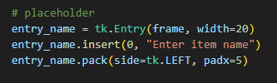
This forms a text input box when typing item name. The width parameter is used to regulate the size of the input box.
This puts some dummy text at position 0 (at the start of the field). It directs the user on what to type.
This puts the entry field within the frame on the left side separated by a horizontal (padx=5).
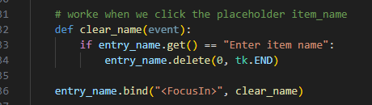
This is the inner functionality to be executed upon user action on the entry field.
when entry name.get is equal to Enter item name:
This is to verify whether the text that is there is the placeholder.
This clears out all the text in the entry field as the user clicks on the entry field.
This ties the functionality with the occurrence when the user mouse clicks within the field (FocusIn). It allows interactive interaction.
(The same argument applies to price field, but we can explain it in the same way)
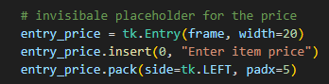
This adds the two fields of entries (name and price) into the list as a couple. This enables the program to subsequently go over all items.

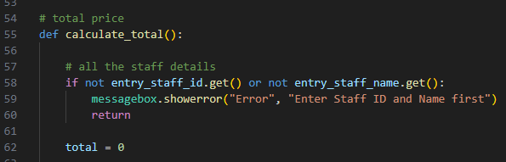
Comes up with a method to compute the total price of all the items entered.
Declares a variable to hold the overall sum.
where name is the name of the item, price is the price of the item, and item entries are name-price entries:
Repeatedly visits every element in the list.

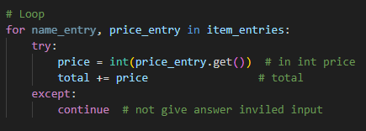
Gets the price typed in by the user and makes it an integer to calculate.
Sums up all prices of items.
The program does not crash upon the user entering invalid data (e.g. text, not number).
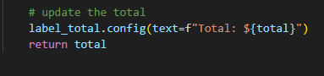
Dynamically updates the label to show the total cost.
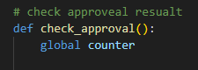
Identifies a function to help it decide whether the requisition is accepted or in progress.
Allows changing the global variable counter.
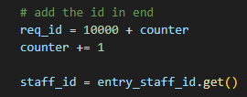
Produces a requisition ID.
Checks approval condition.
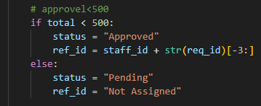
Forms a reference ID as staff ID + last three digits of the requisition ID.
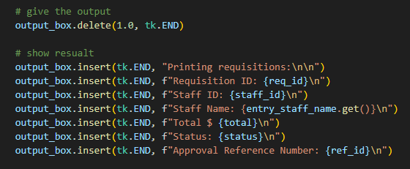
Erases what has been typed in the text box.
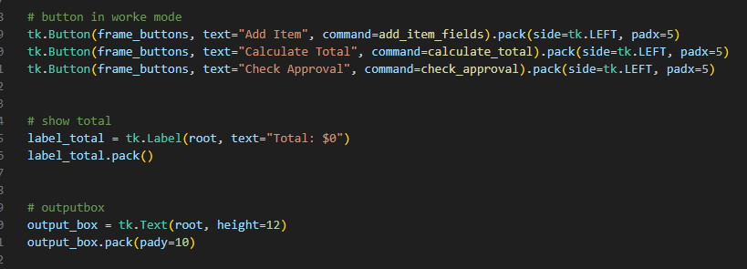
Displays results line by line in the output area.

Task-4 outputs.

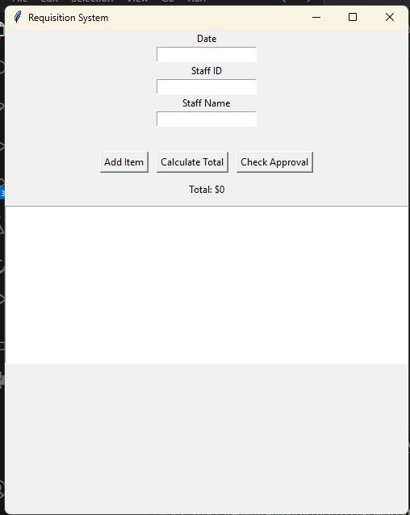
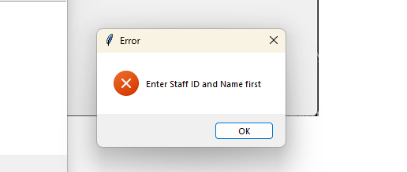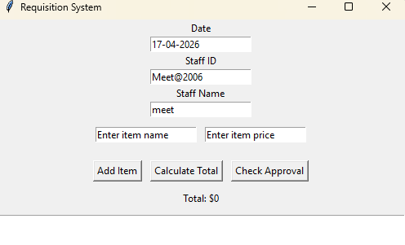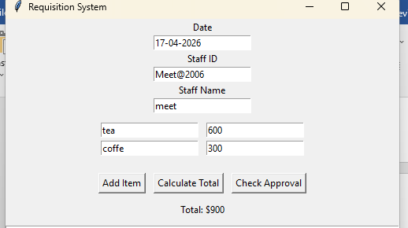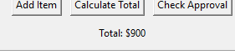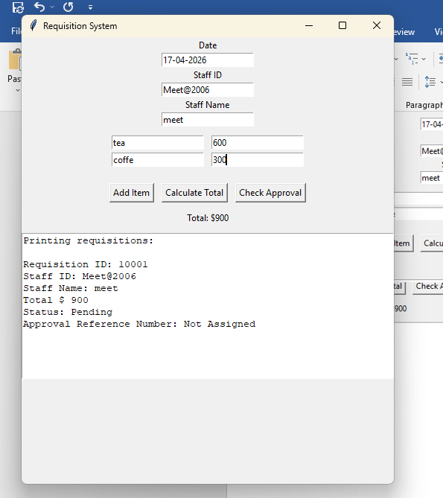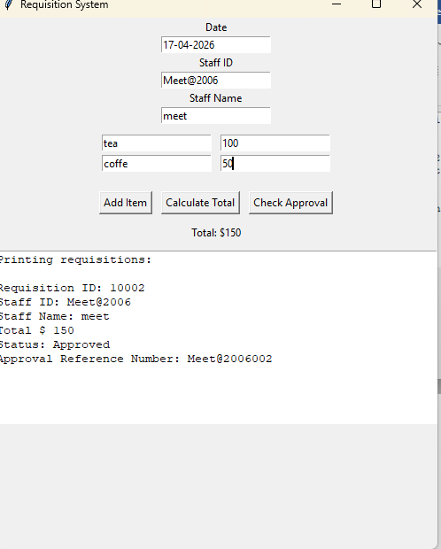

References
GeeksforGeeks. (2026, 04 17). Retrieved from GeeksforGeeks: https://www.geeksforgeeks.org/python/python-tkinter-frame-widget/
python.org. (2026, 04 17). Retrieved from python.org: https://docs.python.org/3/library/tkinter.html#the-packer
pythonexamples.org. (2026, 04 17). Retrieved from pythonexamples.org: https://pythonexamples.org/python-tkinter-entry-focus-in-and-focus-out/#google_vignette

